***Low-Level Design for MovieLens Dataset Analysis Project***

**1. Introduction**

This document presents the low-level design for the MovieLens dataset analysis project, leveraging Spark and Python. The objective of the project is to perform analytical tasks on a semi-structured dataset containing a million records from MovieLens. The analysis aims to derive insights about users and movies using various Spark APIs, including RDD, Spark SQL, and DataFrame. This document provides detailed information about the system architecture, algorithms, and implementation details.

**2. System Architecture**

The system architecture for the MovieLens dataset analysis project consists of the following components:

* **Data Source**: The MovieLens dataset, containing a million records, serves as the data source for analysis.
* **Spark Cluster**: A cluster of machines is used to distribute the data and computations using Spark's distributed processing capabilities.
* **PySpark**: The Python API for Apache Spark is utilized to leverage Spark's functionalities and perform data processing and analysis.

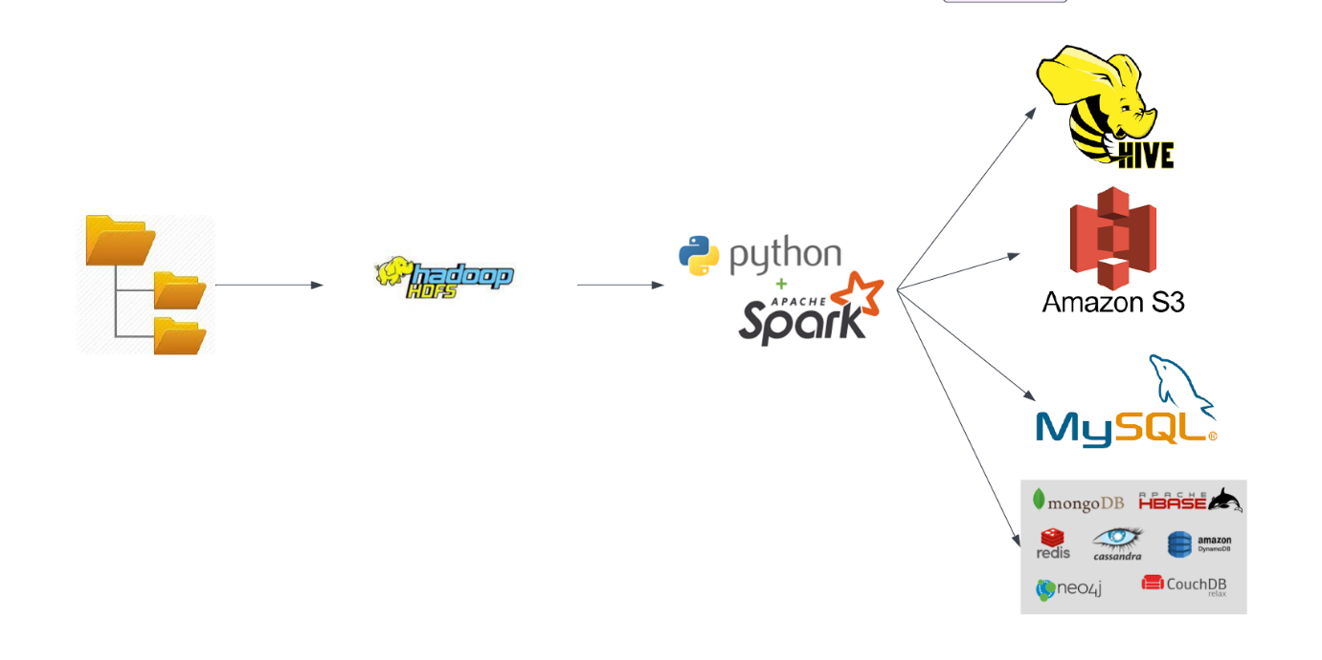

**3. Data Flow**

* + Provide a detailed data flow diagram illustrating the flow of data through the different modules and components.
  + Show how data is ingested, processed, and analyzed, and how the resultant output can be utilized.

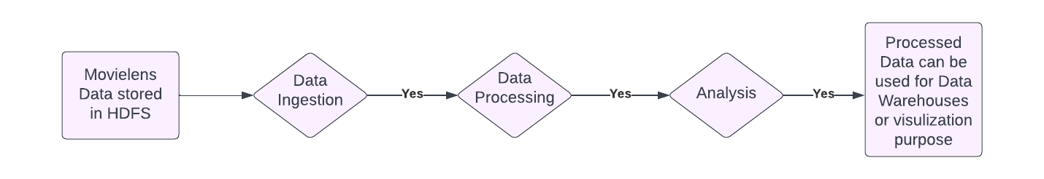

**4. Algorithm Design**

The algorithmic design involves the following steps and techniques:

***4.1 Data Loading and Pre-processing***

* The MovieLens dataset is loaded into Spark using the `spark.read` API, reading the data from the source file.
* Data preprocessing is performed to handle missing values, remove irrelevant columns, and transform the data into a suitable format for analysis.

***4.2 Data Analysis Tasks***

The following analysis tasks are performed using Spark RDD, Spark SQL, and DataFrame:

* *4.2.1 Task 1: User Analysis*
* How many numbers of movies are there for each rating?
* How many users have rated each movie?
* *4.2.2 Task 2: Movie Analysis*
* What are the top 10 most viewed movies?
* What are the distinct list of genres available?
* How many movies for each genre?
* How many movies are starting with numbers or letters (Example: Starting with 1/2/3../A/B/C..Z)?
* List the latest released movies
* How many movies are released each year?
* How many number of movies are there for each rating?
* How many users have rated each movie?
* What is the total rating for each movie?
* What is the average rating for each movie?
* *4.2.3 Task 3: Rating Analysis*
* How many number of movies are there for each rating?
* How many users have rated each movie?
* What is the total rating for each movie?
* What is the average rating for each movie?

***4.3 Algorithm Implementation Details***

The algorithms for the analysis tasks utilize the following Spark APIs and techniques:

* **Spark RDD:**

RDDs are used for efficient distributed processing and transformations of the MovieLens dataset. Operations like map, filter, and reduceByKey are applied to perform computations on RDDs.

* **Spark SQL:**

Spark SQL is used for executing SQL-like queries on the dataset, enabling structured data processing and analysis. DataFrames are used to leverage Spark SQL's optimized execution engine and perform efficient operations on structured data.

* **Broadcast Variables:**

Broadcast variables are used to efficiently distribute read-only data, such as lookup tables, to all nodes in the Spark cluster. They are utilized to share large reference data with the workers, enhancing performance by reducing network communication and data transfer.

* **Accumulators**:

Accumulators are employed to aggregate values across different computations in a distributed manner. They are used to track specific metrics or statistics during the analysis, providing an efficient mechanism for collecting and aggregating information across the Spark cluster.

***5. Implementation Details***

The implementation of the MovieLens dataset analysis project involves the following steps:

* **Data loading**: Load the MovieLens dataset into Spark using the `spark.read` API, specifying the file path and format.
* **Data pre-processing**: Perform data pre-processing tasks such as handling missing values, removing irrelevant columns, and transforming the data into a suitable format for analysis.
* **Algorithm implementation:** Implement the algorithms for the analysis tasks using Spark RDD, Spark SQL, and DataFrame. Utilize Spark SQL queries, RDD transformations, and actions to perform the required computations.
* **Broadcast variables:** Create and utilize broadcast variables to efficiently share reference data, such as movie genre lookup tables, across all nodes in the Spark cluster.
* **Accumulators:** Initialize accumulators to track specific metrics or statistics during the analysis, such as counting the number of movies per genre or users' average ratings.
* Execute the analysis tasks: Run the implemented algorithms on the MovieLens dataset, leveraging Spark's distributed processing capabilities to perform efficient data analysis.
* **Resultant output**: Capture the output of the analysis tasks, which can be further utilized for various purposes such as generating reports, visualizations, or feeding into downstream applications for decision-making processes.

**6. Conclusion**

The low-level design document provides a detailed technical overview of the MovieLens dataset analysis project, outlining the components, modules, and their interactions. It serves as a guide for implementation and development, ensuring a clear understanding of the system's design and functionality.